ENTRY METHOD: FIRST RECEIVED
First received entries will be taken beginning
Mar 11, 2024 at 9am (Eastern Daylight Time)
The closing date will be May 3, 2024 at 5pm (Eastern Daylight Time)
If necessary, a wait list will be made from the remaining entries after limits have been reached. Limit of 50 dogs on the wait list. No more than 10 dogs’ entries per envelope.
PREMIUM LIST
Youngsville Agility Club of North Carolina
(Licensed by the American Kennel Club)
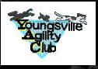
Sat, May 11, 2024 Event # 2024625614 (Trial 1) | Sat, May 11, 2024 Event # 2024625615 (Trial 2)
Sun, May 12, 2023 Event #2024625617 (Trial 1) | Sun, May 12, 2023 Event #2024625616 (Trial 2)
Trial Site: Teamworks Dog Training, 195 Robbins Rd, Youngsville, NC 27596
Entry limits: No more than 8 hours per judge
To be held: Outdoors, outdoors under cover, and indoors
Trial Hours:
Saturday and Sunday: 7:30am – 6:00pm
Judges:
Shannon Jones – Judge # 95361 (Cary, NC)
Connie Kniseley – Judge # 108749 (Roanoke, VA)
Joanne Kuchinski – Judge # 101761 (Raleigh, NC)

Trial Hours:
7:30am-6:00pm
Judge’s briefing at 8am
CLASSES OFFERED
Saturday |  | Sunday
Container (2 Trials)  Novice A & B, Advanced, Excellent, Master |  | Container (2 Trials)  Novice A & B, Advanced, Excellent, Master
Interior (2 Trials)  Novice A & B, Advanced, Excellent, Master |  | Interior (2 Trials)  Novice A & B, Advanced, Excellent, Master
Buried (2 Trials)  Novice A & B, Advanced, Excellent, Master |  | Buried (2 Trials)  Novice A & B, Advanced, Excellent, Master
Exterior (2 Trials)  Novice A & B, Advanced, Excellent, Master |  | Exterior (2 Trials)  Novice A & B, Advanced, Excellent, Master
*Judging Assignments & class order may be revised to balance judging loads and will be announced in the final confirmation letter. Note the order above is NOT a class order.
Connie M Kniseley  Judge's Number: 108749 | 5606 PLAIN VIEW AVE  ROANOKE, VA 24019-1706
Shannon Jones  Judge's Number: 95361 | 600 N Harrison Ave  Cary, NC 27513-4607
Joanne Kuchinski  Judge’s Number: 101761 | 3806 BRENTWOOD RD APT C  RALEIGH, NC 27604-1703
OFFICERS OF THE YOUNGSVILLE AGILITY CLUB
President / Scent Work Trial Secretary: |  | Michele Godlevski
Vice President: |  | Lisa Rogers
Treasurer: |  | Greg Godlevski
Club Secretary: |  | Sheila McHugh
TRIAL CHAIRPERSON |  | TRIAL SECRETARY
Jules Asbed  1106 Penelope Lane  Williamston, NC 27892  Email: hattrickpwds@gmail.com  Mobile: 251-463-5663 |  | Michele Godlevski  195 Robbins Road  Youngsville, NC 27596  Email: teamworkstrialsecretary@gmail.com  Mobile: 919-696-5558
EVENT COMMITTEE
Jules Asbed, Michele Godlevski, Betsy Wood, Lisa Rogers, Betsy Wood, Greg Godlevski
VETERINARIAN ON CALL |  |  | EMERGENCY SERVICES (people)
Blue Pearl Veterinary Clinic  4640 Paragon Park Rd, Raleigh, NC 27616  (919) 861-0109 |  |  | Heritage Urgent & Primary Care  620 Dr Calvin Jones Hwy #212,  Wake Forest, NC 27587  (919) 761-5678

OFFICERS OF THE YOUNGSVILLE AGILITY CLUB
President / Scent Work Trial Secretary: | Michele Godlevski
Vice President: | Lisa Rogers
Treasurer: | Greg Godlevski
Club Secretary: | Sheila McHugh

SITE INFORMATION – Teamworks Dog Training
Trial Site: It is not appropriate to visit the trial location for practice the day before the trial date.
- Teamworks Dog Training does offer RV parking on site, but you must adhere to the signs that indicate to stay out of where the search areas are, even when it is not trial hours. RV Parking with 30 amp hookups is available on site by reservation only. See this page for reservations: http://www.teamworksdogtraining.org/rentals-reservations/.
- There will be NO crating indoors. Please plan to crate out of your car and bring shade and fans for your dog.
- All dogs must be on leash at all times except when in the search area.
- Teamworks Dog Training will not be responsible for any lost or damaged items left at the show site.
- The safety of the dogs is our primary concern. By entering this trial, exhibitors acknowledge that they are familiar with the rules and regulations of this sport.
- It is expressly understood that exhibitors alone are responsible for the behavior of their dog(s) and/or children. Any exhibitor whose dog(s) and/or children create unnecessary disturbances or repeatedly engage in unsafe or disruptive behavior may, at the discretion of Teamworks Dog Training, be asked to leave the show site. In that case, no refund of any fees paid will be made.
- Any handler who is found to abuse a dog will be disqualified and reported to AKC.
- You must clean up after your dog. If a handler is found to violate this rule, future entries will be refused.
- Interior will be held inside the Training Hall, the Wag Center and other nearby structures. Exterior, Buried, and Containers will be held on the grounds, either outside or under cover.
- Coffee, bottled water, and individually-wrapped snacks will be available in the clubhouse.
- Lunch will be available each day for an additional fee
or at no cost to anyone who volunteers to help.

Teamworks Dog Training Youngsville location site map
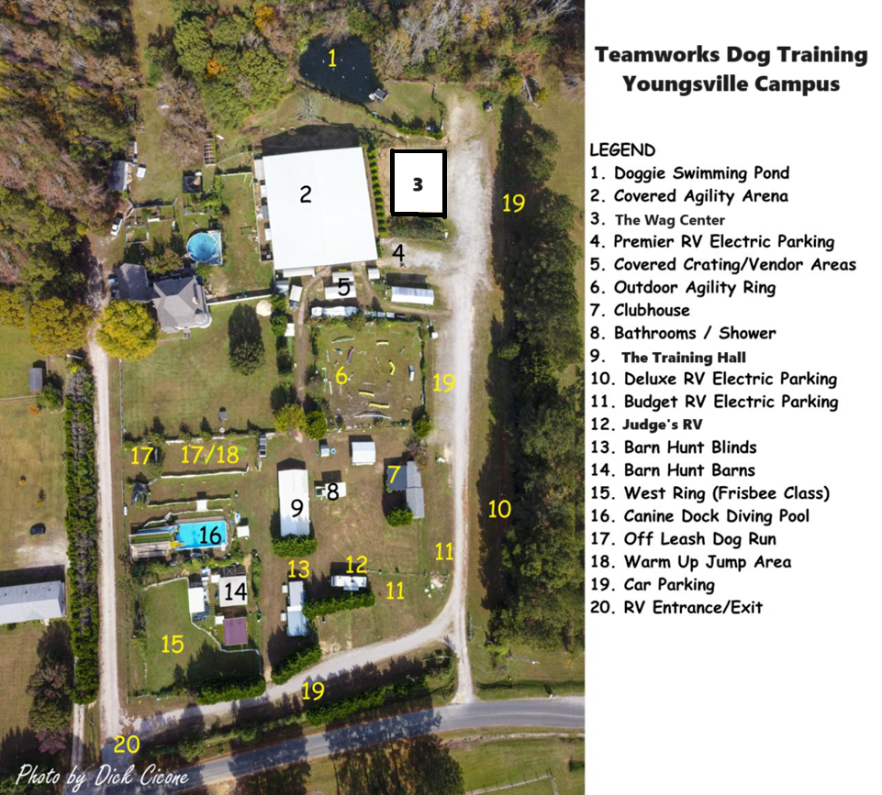

Move-Ups: Move-ups will only be allowed from Saturday to Sunday. Additional fees will apply.
SORRY, NO DAY OF SHOW MOVE-UPS.
Class Requirements
Novice A Classes: are open to dogs who have not completed any Scent Work title for that particular element, and who have never worked as professional detection dogs.
Novice B Classes: are open to all dogs. Dogs who have earned titles in other scent detection organizations or who have worked as professional detection dogs should enter the B class.
Advanced Classes: are open to dogs who have already earned the Novice title for that element.
Excellent Classes: are open to dogs who have already earned the Advanced title for that element.
Master Classes: are open to dogs who have already earned the Excellent title for that element.
DOGS ELIGIBLE TO ENTER
This trial is open to all dogs six months of age or older that are registered with the American Kennel Club, or have an AKC Limited Registration, an AKC Purebred Alternative Listing, an AKC Indefinite Listing Privilege, an AKC Canine Partners number, or a Foundation Stock Service Breed listing number.
Dogs with a Purebred Alternative Listing or Indefinite Listing Privilege or Canine Partners number must be spayed or neutered in order to compete. Dogs with physical challenges, including amputees, are eligible to participate provided that, in the opinion of the judge, the dog displays no sign of physical discomfort and can safely perform the search. Deaf and blind dogs are allowed to enter. Females in season may NOT participate. BIS refunds will be issued with a veterinarian’s note, certifying the dog is in heat. No dog can compete with sutures, bandages, or visible wounds.

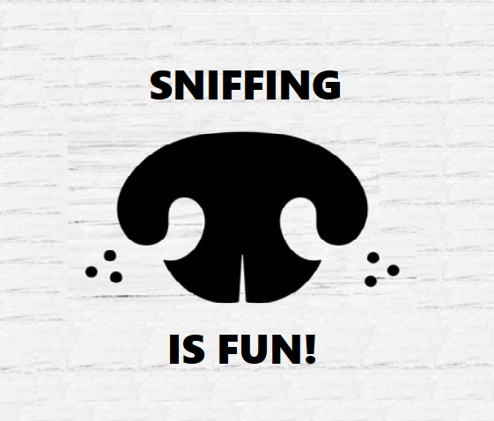
ENTRY FEES PER TRIAL
Novice A/B: $25 per class; Advanced $30 per class; Excellent $35 per class; Master $40 per class; (Each entry includes a $3.50 AKC recording fee)
PREFERRED: Email entries to teamworkstrialsecretary@gmail.com
with PayPal payment to YoungsvilleAgilityClub@gmail.com
-or-
Mail entries (USPS not recommended) to Michele Godlevski, 195 Robbins Rd, Youngsville, NC 27596
No entries will be accepted before the opening date and time.
Illegible entries will be returned. Entries without fees do not constitute a valid entry.
Returned checks will not constitute a valid entry and will be charged an additional $35 fee.
Entries close at the posted time and date, after which time no entries will be accepted, cancelled, or refunded. Acknowledgement of entries will be made within a week of receipt of entry. Please contact trial secretary if acknowledgement is not received within this timeframe.
Entries not on an official AKC entry form with rules, wavier, and signature will not be valid. Entries without payment will not be valid.
DO NOT SEND ENTRIES AS “SIGNATURE REQUIRED”.
RIBBONS AND AWARDS
First Place…………………………………Blue Placement Ribbon
Second Place…………………………………Red Placement Ribbon
Third Place…………………………………Yellow Placement Ribbon
Fourth Place…………………………………White Placement Ribbon
Qualifying…………………………………Dark Green Rosette
New Title…………………………………Aqua Rosette
Overall Title (Novice-Excellent)…………………………………Aqua Neck Rosette
Masters Overall Title……………………………Large Aqua and Black Rosette
High in Trial……………………………….……..Turquoise & Black Rosette with paw prints or medal
WAIT LIST INFORMATION
The Youngsville Agility Club of NC will offer a wait list to fill openings withdrawn after the entry limit is reached. No entries may be withdrawn with a refund after the closing date. Any wait list entry that does not receive a spot in the trial will receive a full refund.
STAGING AREA
The staging area will be out of view of the search area. The search area will be clearly marked with flagging tape and signs. The staging area will include a warm-up and waiting area, as well as a hospitality area.
HANDLER’S BRIEFING
The handler’s briefing will take place in view of the search area prior to the start of each class, after the hides have been set, and after the demo dog has run. In the handler’s briefing, the judge will explain if there is an off-leash option, the maximum number of hides, and the maximum time for the search. NO DOGS MAY BE PRESENT FOR THE HANDLER’S BRIEFING.

WARM-UP AREA
The warm-up area will have one labeled container per target odor, as well as blank containers. Exhibitors should limit their warm-up to one minute or less. The warm-up area is to be used exclusively for warming up the handler and dog and should not be used for relieving the dog.

NOTICE TO EXHIBITORS – IMPORTANT – PLEASE READ
Safety, Behavior, and Liability: The safety of the dog is our primary concern. By entering this trial, exhibitors acknowledge that they are familiar with the rules and regulations of this sport, and that their dogs are familiar with and able to perform all searches safely. It is expressly understood that exhibitors alone are responsible for the behavior of their dogs, children, and spectators. Any exhibitor whose dogs, children, or spectators create an unnecessary disturbance or engage in unsafe or disruptive behavior may be asked to leave the show site. In such case, no refund of any fees will be made. Teamworks Dog Training, and its agents, owners, and employees will assume no responsibilities for any loss damage or injury sustained by exhibitors or handlers or to any of their dogs or property, and further assumes no responsibility for injury to children or spectators. Youngsville Agility Club of NC and its agents, owners, and employees will assume no responsibilities for any loss damage or injury sustained by exhibitors or handlers or to any of their dogs or property, and further assumes no responsibility for injury to children or spectators. No one shall have any recourse or claim against Teamworks Dog Training, or the Youngsville Agility club of North Carolina, or any official thereof. The competitor expressly agrees that AKC and Teamworks Dog Training, and the Youngsville Agility Club of NC and any other person of said groups shall not be held liable personally or collectively, under any circumstances, for injury, and/or damages to him/herself, for loss, or damage to property, whether due to uncontrolled dogs or weather, or negligence or any other causes. The competitor agrees to assume all financial liability that may be incurred due to the actions of themselves or their dogs while on the property of the trial site.
COLLARS, LEASHES AND HARNESSES
As per Chapter 5, Section 9 of the AKC Regulations for Scent Work Dogs must wear a properly fitted collar or harness approved by the judge. The harness will be constructed of plain, pliable material and will be designed so that there is minimal restriction of the dog’s movement. No special training tools, such as electronic collars, prong collars, head halters, or no-pull harnesses will be permitted during the search. Martingale collars are permitted. No odor-emitting collars (such as no-bark collars that spray citronella, or DAP calming collars) may be worn or present in the search area. A wearable camera such as a Go Pro may be mounted to the dog’s harness, if desired. Dogs must enter and exit the search area with the leash attached to the collar or harness, including when waiting in the search area before and after their search. The leash should be made of plain, pliable material. Any length of leash and/or retractable leashes are permitted for use during the search. The leash can be used to gently guide the dog away from the boundaries of the search area, but cannot be used as a correction device. Most searches will be conducted entirely on leash, but an off-leash option may be offered at trial.

SCENT WORK TRIAL RULES
Possession of Odors and Training: Chapter 5. Section 26 of the Scent Work Regulations state that “No person other than those engaged in the administration of a trial shall be in possession of any target odor when on the trial grounds. There shall be no training on the grounds of the AKC Scent Work trial, other than in the designated warm-up area”
Spectator Area: Any person not handling a dog in the current class or any person who has already completed their run in the current class may choose to watch the search from the designated spectator area. No person outside the search area may assist the handler or disclose the location of the hide. Spectators who give aid to a team will be asked to leave the area by the judge. Spectators may not discuss details of the search with handlers who have not run the class yet.

REFUNDS
No entry fee will be refunded if the trial cannot open or be completed by reason of riots, civil disturbances, fire, an act of God, public emergency, act of a public enemy, or any other cause beyond the control of the organizing committee. No entry fee will be refunded in the event a dog is absent, disqualified, excused, or barred from competition by the action of the Trial Committee. Dogs pulled after closing because of injury or other medical conditions are eligible to a 50% refund by supplying the Trial Secretary with a certificate from your veterinarian dated the day of the trial(s). An Administrative Fee of $5.00 will be withheld from all refunds for entries cancelled prior to the closing of entries.
BITCHES IN SEASON
Bitches in season are not allowed on site. All but $5.00 of each entry fee may be refunded for bitches who come in season after the closing date by supplying the Trial Secretary with a certificate from your veterinarian dated the day of the trial.
EXHIBITOR RULES
Judges are not required to wait for dogs. The Owner of each dog is solely responsible for having it ready at the search area when it is to be judged. The Club has no responsibility to provide service through a public address system or stewards or runners for the purpose of calling or locating dogs that are not brought into the ring when required.
Exhibitor check-In: Dogs may arrive at any time prior to their scheduled time of judging. Dogs not required for further judging are free to leave the trial site. All dogs present must be held on leash or confined to their crates except when being judged. Judges will not wait for any dog holding up a class. Owners or agents are responsible for the presence of their dogs in judging ring when their classes are called. Exhibitors should follow their veterinarian’s recommendation to assure their dogs are free of internal and external parasites, any communicable diseases, and have appropriate vaccinations.
All exhibitors should obtain a copy of the Regulations for Scent Work Trials by downloading them from the American Kennel Club website.
Claims will be arbitrated as set forth on the Official AKC Entry Form for this event.

DOG FRIENDLY LODGING – NEAR TEAMWORKS
RVs: We have 9 RV sites with 30 amp electric hook ups. No water or sewer service available. Online reservations are available at http://www.teamworksdogtraining.org/rentals-reservations/ For questions your reservation, please email michelegodlesvki@gmail.com.
Hotels: Please see http://www.teamworksdogtraining.org/teamworks-events/pet-friendly-hotels/
Hampton Inn on Wake Union Church Rd in Wake Forest ( 20 minutes away)
Holiday Inn Express on Common Oaks Drive in Raleigh (20 minutes away)
Candlewood Suites on Retail Drive in Wake Forest (20 minutes away)
LaQuinta on Westinghouse Blvd in Raleigh (30 minutes away)
Quality Comfort Suites on Capital Blvd in Raleigh (30 minutes away)
DIRECTIONS TO THE TEAMWORKS TRIAL SITE
Teamworks Dog Training is located at 195 Robbins Rd, Youngsville, NC 27596
From Raleigh: Take the 440 beltline to Capital Blvd (Rt 1) North. Merge right onto Route 401 North. Stay on the 401 Bypass through Rolesville (no turns required). Take highway 98 East towards Bunn. Pass Spencer’s Gate housing development. Make the next paved right onto Bethlehem Church Rd. Make the first paved left onto Robbins Rd. At 195 Robbins Rd, veer right to the business driveway. Park in a single row along the fence as indicated by the signage.
From Durham and points West: Take 40 East to 540 East towards Raleigh/Wake Forest. Take Route 401 North. Stay on the 401 Bypass through Rolesville (no turns required). Take highway 98 East towards Bunn. Pass Spencer’s Gate housing development. Make the next paved right onto Bethlehem Church Rd. Make the first paved left onto Robbins Rd. At 195 Robbins Rd, veer right to the business driveway. Park in a single row along the fence as indicated by the signage.
From I-95 and points North: Take 95 South to Route 85 South towards Raleigh. AFTER crossing into North Carolina, take the left exit to Route 1 S. Take Route 98 East towards Bunn. Pass Spencer’s Gate housing development. Make the next paved right onto Bethlehem Church Rd. Make the first paved left onto Robbins Rd. At 195 Robbins Rd, veer right to the business driveway. Park in a single row along the fence as indicated by the signage.
From I-95 and points South: Take 95 North towards Raleigh. Get off at the Wilson exit for 264 West. 264 merges with 64 West. Get off at Route 96 North in Zebulon. Take Route 96 N to Route 401 North. Take highway 98 East towards Bunn. Pass Spencer’s Gate housing development. Make the next paved right onto Bethlehem Church Rd. Make the first paved left onto Robbins Rd. At 195 Robbins Rd, veer right to the business driveway. Park in a single row along the fence as indicated by the signage.
From Sanford and points Southwest: Take 1 North towards Raleigh. Get on the 440 beltline headed North towards Wake Forest. Exit at the 64/264 highway exit (not 64 business). Take 64/264 East. Get off at Route 96 North in Zebulon. Take Route 96 N to Route 401 North. Take highway 98 East towards Bunn. Pass Spencer’s Gate housing development. Make the next paved right onto Bethlehem Church Rd. Make the first paved left onto Robbins Rd. At 195 Robbins Rd, veer right to the business driveway. Park in a single row along the fence as indicated by the signage.

May 11-12, 2024
Youngsville Agility Club Scent Work Trials
195 Robbins Road, Youngsville, North Carolina 27596
Email entry with PayPal payment is preferred. Email entries to teamworkstrialsecretary@gmail.com with PayPal payment to YoungsvilleAgilityClub@gmail.com . Entries are NOT confirmed until both completed form and payment are received. USMail entries to address above. Checks should be made payable to the Youngsville Agility Club of NC.
Entry fees: Novice $25 / class; Advanced $30 /class; Excellent $35 / class; Master $40/class
Dog’s Call Name: |  |  | Handler’s Name:
 | Sat Trial 1 | Sat Trial 2 | Sun Trial 1 | Sun Trial 2
BURIED | - Novice A  - Novice B  - Advanced  - Excellent  - Master | - Novice A  - Novice B  - Advanced  - Excellent  - Master | - Novice A  - Novice B  - Advanced  - Excellent  - Master | - Novice A  - Novice B  - Advanced  - Excellent  - Master |  | $
CONTAINERS | - Novice A  - Novice B  - Advanced  - Excellent  - Master | - Novice A  - Novice B  - Advanced  - Excellent  - Master | - Novice A  - Novice B  - Advanced  - Excellent  - Master | - Novice A  - Novice B  - Advanced  - Excellent  - Master |  | $
INTERIOR | - Novice A  - Novice B  - Advanced  - Excellent  - Master | - Novice A  - Novice B  - Advanced  - Excellent  - Master | - Novice A  - Novice B  - Advanced  - Excellent  - Master | - Novice A  - Novice B  - Advanced  - Excellent  - Master |  | $
EXTERIOR | - Novice A  - Novice B  - Advanced  - Excellent  - Master | - Novice A  - Novice B  - Advanced  - Excellent  - Master | - Novice A  - Novice B  - Advanced  - Excellent  - Master | - Novice A  - Novice B  - Advanced  - Excellent  - Master |  | $
TOTAL AMOUNT DUE: $

Form of payment submitted: | PayPal | Check |

INSTRUCTIONS
Please check the box for each class desired to be entered. Dogs entering the Advanced, Excellent, or Master classes must have earned the required title, as stipulated in the AKC Scent Work Regulations.
The same handler cannot show more than one dog in the same class of the same trial on the same day.
AKC Registered Name: |  |  | Registration Number:  AKC/PAL/ILP/CP Foreign
Call Name: | Date of Birth: |  |  |  |  |  | Male/Female
Breed: |  |  |  |  | Variety:
Breeder:
Sire:
Dam:
Owner:
Owner Address:
City: |  | State: |  |  |  | Zip:
Telephone: |  |  |  | Email:
Handler Name:
Fields marked in blue are REQUIRED. Fields marked in gray must be completed if the information is known.
***Be sure to read the Agreement below and sign it. No form will be processed without your signature!***
AKC Rules, Regulations, Policies and Guidelines are available on the
American Kennel Club Web site, www.akc.org

AGREEMENT
I certify that I am the actual owner of the dog, or that I am the duly authorized agent of the actual owner whose name I have entered. In consideration of the acceptance of this entry, I (we) agree to abide by the rules and regulations of The American Kennel Club in effect at the time of this event, and any additional rules and regulations appearing in the premium list of this event and entry form and any decision made in accord with them. I (we) agree that the club holding this event has the right to refuse this entry for cause which the club shall deem sufficient. I (we) certify and represent that the dog entered is not a hazard to persons or other dogs. In consideration of the acceptance of this entry and of the holding of this event and of the opportunity to have the dog judged and to win prizes, ribbons, or trophies, I (we) agree to hold the AKC, the event-giving club, their members, directors, governors, officers, agents, superintendents or event secretary and the owner and/or lessor of the premises and any provider of services that are necessary to hold this event and any employees or volunteers of the aforementioned parties, and any AKC approved judge, judging at this event, harmless from any claim for loss or injury which may be alleged to have been caused directly or indirectly to any person or thing by the act of this dog while in or about the event premises or grounds or near any entrance thereto, and I (we) personally assume all responsibility and liability for any such claim; and I (we) further agree to hold the aforementioned parties harmless from any claim of loss, injury or damage to this dog. Additionally, I (we) hereby assume the sole responsibility for and agree to indemnify, defend and save the aforementioned parties harmless from any and all loss and expense (including legal fees) by reason of the liability imposed by law upon any of the aforementioned parties for damage because of bodily injuries, including death at any time resulting there from, sustained by any person or persons, including myself (ourselves), or on account of damage to property, arising out of or in consequence of my (our) participation in this event, however such, injuries death or property damage may be caused, and whether or not the same may have been caused or may be alleged to have been caused by the negligence of the aforementioned parties or any of their employees, agents, or any other person. I (we) agree that the determination of whether the injury is serious shall be made by the event veterinarian and is binding on me (us). I (WE) AGREE THAT ANY CAUSE OF ACTION, CONTROVERSY OR CLAIM ARISING OUT OF OR RELATED TO THE ENTRY, EXHIBITION OR ATTENDANCE AT THE EVENT BETWEEN THE AKC AND THE EVENT-GIVING CLUB (UNLESS OTHERWISE STATED IN THIS PREMIUM LIST) AND MYSELF (OURSELVES) OR AS TO THE CONSTRUCTION, INTERPRETATION AND EFFECT OF THIS AGREEMENT SHALL BE SETTLED BY ARBITRATION PURSUANT TO THE APPLICABLE RULES OF THE AMERICAN ARBITRATION ASSOCIATION. HOWEVER, PRIOR TO ARBITRATION ALL APPLICABLE AKC BYLAWS, RULES, REGULATIONS, AND PROCEDURES MUST FIRST BE FOLLOWED AS SET FORTH IN THE AKC CHARTER AND BYLAWS, RULES, REGULATIONS, PUBLISHED POLICIES AND GUIDELINES.

SIGNATURE of owner or his agent duly authorized to make this entry:
SIGN HERE:_________________________________________________________________________
PRINT NAME HERE: __________________________________________________________________
Phone #: _______________________ Email: ___________________________________________
In case of Emergency – Name: ________________________________ Phone #: ________________

ENTRIES WITHOUT SIGNED WAIVER OR WITHOUT PAYMENT WILL NOT CONSTITUTE A VALID ENTRY FORM

